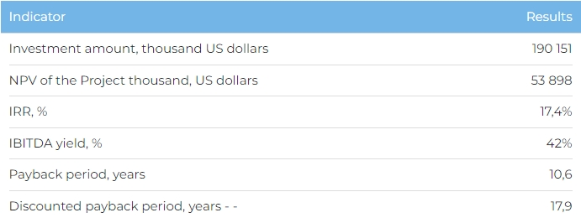
Project description:

Development of a multifunctional resort complex ("Complex") in Burabay resort area, on the shores of Bolshoye Chebachye and Tekekol lakes, with a year-round operational schedule.

Location:

Akmola region, Burabay resort area, the shores of Bolshoye Chebachye and Tekekol lakes

Project initiator:

Burabay Damu LLP: subordinate organization of the Office of the President's Affairs ("OPA").

Governmental support:

OPA provides a land plot and the government finances construction of engineering infrastructure

Key investment indicators
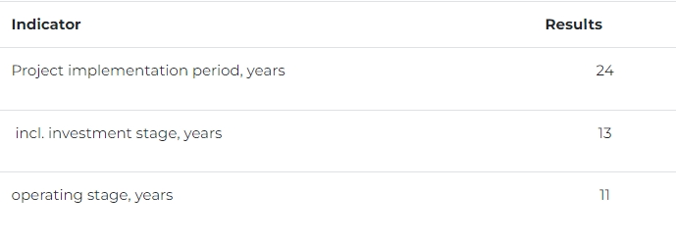
Key facilities of the Complex:
Land plot area

233 hectares

Guest stay facilities

Family hotel;
Hotel for adults;
Hotel for sports events and meetings;
Guest cottage houses and villas.
Total capacity of the guest stay facilities: 800 rooms (1900 beds). Hotel categories: 4/4+.
Market prerequisites:

Growing demand for tourism services The average annual growth in the number of domestic tourists in Kazakhstan in 2013-2017 amounted to 10%, while the number of outbound tourists was almost left unchanged over the last five years. Average annual growth in the number of inbound tourists in 2016-2017 amounted to 18%. In 2017, the number of inbound tourists (mainly from the CIS countries) amounted to 7.7 million people.

Increase in attendance of Burabay resort area

Burabay resort area is one of the most popular resorts in Kazakhstan. In 2017, 150,000 people have stayed at its guest stay facilities. While an estimated total attendance of the resort area came at around 600,000 people over the same period. According to expert forecasts, the average annual growth of the total resort attendance untill the 2030 will be equal to 4.1%.

Low market competition level To date, in Burabay resort area there are no tourist facilities providing a similar array of accomodation and leisure services, and with similar quality standards. The only complex with a similar scale and versatility of the provided services is the "8 lakes" Park resort complex, located near Almaty.

Capacity projections for the Complex by 2040:

Capacity of the guest stay facilities: accommodating 380 thousand tourists per year;

Residential area population: 2000 people;

One-off visits to the leisure and entertainment facilities of the Complex: 3.3 million per year.

Leisure and entertainment facilities

Aqua-park and adventure park;
The ski arena;
Center for learning and entertainment;
Health recreational center;
City center with commercial areas;
Sports complex.
Residential area
340 cottage houses;
84 villas.
Construction of all of the facilities of the Complex is divided into 3 phases, with the planned completion of all construction works in 2030.

